Meera S

21Mca032

SJC21MCA-2034

1. Program to Print all non-Prime Numbers in an Interval

2. Program to print the first N Fibonacci numbers.

3. Given sides of a triangle, write a program to check whether given triangle is an

isosceles, equilateral or scalene.

4. Program to check whether given pair of number is coprime

5. Program to find the roots of a quadratic equation(rounded to 2 decimal places)

6. Program to check whether a given number is perfect number or not(sum of factors

=number)

7. Program to display amstrong numbers upto 1000

8. Store and display the days of a week as a List, Tuple, Dictionary, Set. Also

demonstrate different ways to store values in each of them. Display its type also.

9. Write a program to add elements of given 2 lists

10. Write a program to find the sum of 2 matrices using nested List.

11. Write a program to perform bubble sort on a given set of elements.

12. Program to find the count of each vowel in a string(use dictionary)

13. Write a Python program that accept a positive number and subtract from this

number the sum of its digits and so on. Continues this operation until the number is

positive(eg: 256-&gt;2+5+6=13

256-13=243

243-9=232……..

14. Write a Python program that accepts a 10 digit mobile number, and find the digits

which are absent in a given mobile number

1. Program to Print all non-Prime Numbers in an Interval

lower=int(input("Enter a value for lower digit : "))  
upper=int(input("Enter a value for upper digit : "))  
print("The Non Prime Numbers are : ")  
for i in range(lower,upper):  
 for j in range(2,upper):  
 if(i%j==0) and(j!=i):  
 print(i)  
 break

OUTPUT

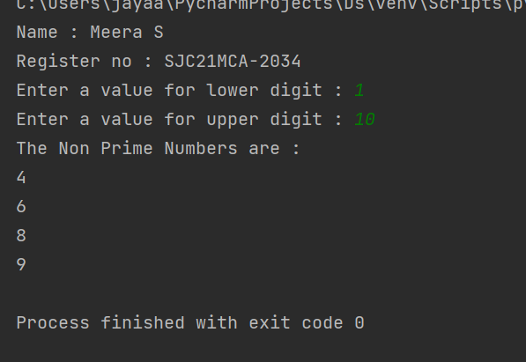

2. Program to print the first N Fibonacci numbers

f1 = 0  
f2 = 1  
for x in range(0, n):  
 print(f2, end=" ")  
 next = f1 + f2  
 f1 = f2  
 f2 = next

OUTPUT



3. Given sides of a triangle, write a program to check whether given triangle is an

isosceles, equilateral or scalene.

print("Name : Meera S")  
print("Register no : SJC21MCA-2034")  
s1 = int(input("Enter the length for Side 1:"))  
s2 = int(input("Enter the length for Side 2:"))  
s3 = int(input("Enter the length for side 3:"))  
if s1 == s2 and s2 == s3 and s3==s1:  
 print("The given lengths are of an Equilateral triangle ")  
elif s1 == s2 or s1 == s3 or s2==s3:  
 print("The given lengths are of an Isosceles triangle")  
else:  
 print("The given lengths are of a Scalar triangle")

OUTPUT

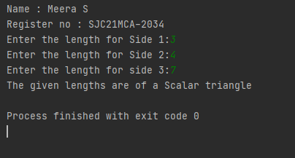

4. Program to check whether given pair of number is coprime

print("Name : Meera S")  
print("Register no : SJC21MCA-2034")  
def are_coprime(a, b):  
 hcf = 1  
  
 for i in range(1, a + 1):  
 if a % i == 0 and b % i == 0:  
 hcf = i  
 return hcf == 1  
first = int(input('Enter first number: '))  
second = int(input('Enter second number: '))  
  
if are_coprime(first, second):  
 print('%d and %d are CO-PRIME' % (first, second))  
else:  
 print('%d and %d are NOT CO-PRIME' % (first, second))

OUTPUT

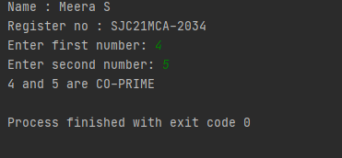

5. Program to find the roots of a quadratic equation(rounded to 2 decimal places)

print("Name : Meera S")  
print("Register no : SJC21MCA-2034")  
from math import sqrt  
print("Quadratic function : (a * x^2) + b*x + c")  
a = float(input("a: "))  
b = float(input("b: "))  
c = float(input("c: "))  
r = b**2 - 4*a*c  
if r > 0:  
 num_roots = 2  
 x1 = (((-b) + sqrt(r))/(2*a))  
 x2 = (((-b) - sqrt(r))/(2*a))  
 print("There are 2 roots: %f and %f" % (x1, x2))  
elif r == 0:  
 num_roots = 1  
 x = (-b) / 2*a  
 print("There is one root: ", x)  
else:  
 num_roots = 0  
 print("No roots, discriminant < 0.")  
 exit()

OUTPUT

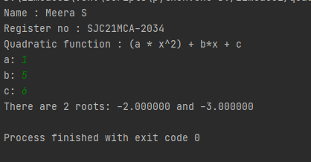

6. Program to check whether a given number is perfect number or not(sum of factors

=number)

print("Name : Meera S")  
print("Register no : SJC21MCA-2034")  
num = int(input("Enter any number: "))  
sum = 0  
for i in range(1, num):  
 if(num % i == 0):  
 sum = sum + i  
if (sum == num):  
 print("The number is a PERFECT Number ")  
else:  
 print("The number is NOT A PERFECT Number !")

OUTPUT

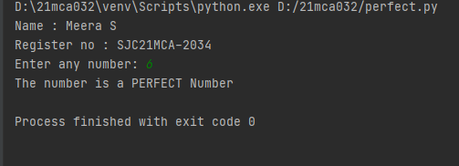

7. Program to display amstrong numbers upto 1000

print("Name : Meera S")  
print("Register no : SJC21MCA-2034")  
for num in range(1, 1000):  
 order = len(str(num))  
 sum = 0  
  
 temp = num  
 while temp > 0:  
 digit = temp % 10  
 sum += digit ** order  
 temp //= 10  
  
 if num == sum:  
 print(num)

OUTPUT

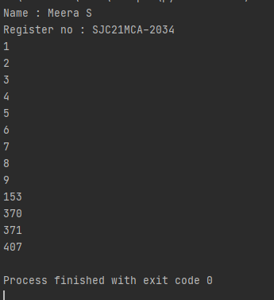

8. Store and display the days of a week as a List, Tuple, Dictionary, Set. Also

demonstrate different ways to store values in each of them. Display its type also.

print("Name : Meera S")  
print("Register no : SJC21MCA-2034")  
list1=["sunday","monday","tuesday","wednesday","thurday","friday","saturday"]  
tuple=("sunday","monday","tuesday","wednesday","thurday","friday","saturday")  
set={"sunday","monday","tuesday","wednesday","thurday","friday","saturday"}  
dict={1:"sunday",2:"monday",3:"tuesday",4:"wednesday",5:"thurday",6:"friday",7:"saturday"}  
print(list1,type(list1))  
print(tuple,type(tuple))  
print(set,type(set))  
print(dict,type(dict))

OUTPUT

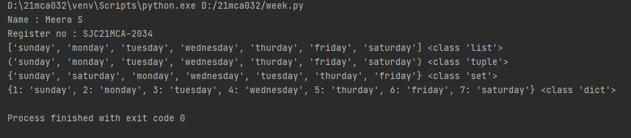

9. Write a program to add elements of given 2 lists

print("Name : Meera S")  
print("Register no : SJC21MCA-2034")  
lt1 = []  
lt2 = []  
lt3 = []  
  
items = int(input(" Enter the total number of the list elements: "))  
  
print(" Enter the items into List 1 : ")  
for i in range(1, items + 1):  
 num = int(input(" Enter the value of %d index is :" % i))  
 lt1.append(num)  
  
print(" Enter the items into the List 2 : ")  
for i in range(1, items + 1):  
 num = int(input(" Enter the value of %d index is :" % i))  
 lt2.append(num)  
  
for j in range(items):  
 lt3.append(lt1[j] + lt2[j])  
print("\n Addition of the two lists is ", lt3)

OUTPUT

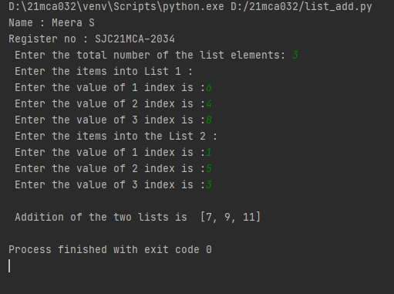

10. Write a program to find the sum of 2 matrices using nested List.

print("Name : Meera S")  
print("Register no : SJC21MCA-2034")  
rows = int(input("Enter the Number of rows : "))  
column = int(input("Enter the Number of Columns: "))  
  
print("Enter the elements of First Matrix:")  
matrix_a = [[int(input()) for i in range(column)] for i in range(rows)]  
print("First Matrix is: ")  
for n in matrix_a:  
 print(n)  
  
print("Enter the elements of Second Matrix:")  
matrix_b = [[int(input()) for i in range(column)] for i in range(rows)]  
for n in matrix_b:  
 print(n)  
  
result = [[0 for i in range(column)] for i in range(rows)]  
  
for i in range(rows):  
 for j in range(column):  
 result[i][j] = matrix_a[i][j] + matrix_b[i][j]  
  
print("The Sum of Above two Matrices is : ")  
for r in result:  
 print(r)

OUTPUT

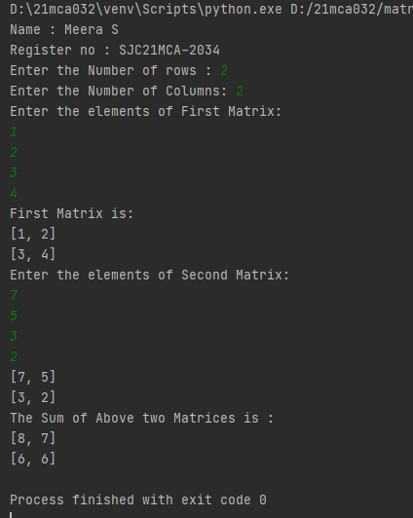

11. Write a program to perform bubble sort on a given set of elements.

print("Name : Meera S")  
print("Register no : SJC21MCA-2034")  
a = []  
number = int(input("Please Enter the Total Elements : "))  
for i in range(number):  
 value = int(input("Please enter the %d Item : " %i))  
 a.append(value)  
  
for i in range(number -1):  
 for j in range(number - i - 1):  
 if(a[j] > a[j + 1]):  
 temp = a[j]  
 a[j] = a[j + 1]  
 a[j + 1] = temp  
  
print("The Result in Ascending Order : ", a)

OUTPUT

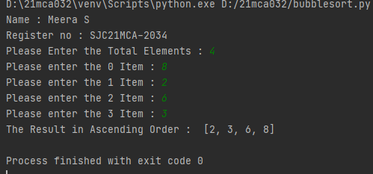

12. Program to find the count of each vowel in a string(use dictionary)

str = input("Enter a string: ")  
count = {x:sum([1 for char in str if char == x]) for x in 'aeiou'}  
print(count)

OUTPUT

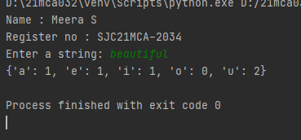

13. Write a Python program that accept a positive number and subtract from this

number the sum of its digits and so on. Continues this operation until the number is

positive(eg: 256-&gt;2+5+6=13

256-13=243

243-9=232……..

print("Name : Meera S")  
print("Register no : SJC21MCA-2034")  
n = int(input("Enter a positive number : "))  
n_str = str(n)  
while (n > 0):  
 n -= sum([int(i) for i in list(n_str)])  
 n_str = list(str(n))  
 print(n)

OUTPUT

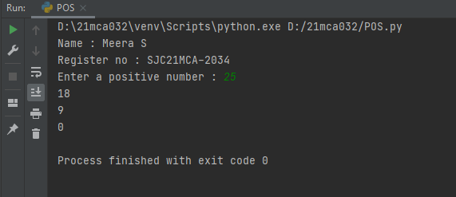

14. Write a Python program that accepts a 10 digit mobile number, and find the digits

which are absent in a given mobile number

num = int(input("Enter a 10 digit mobile number : "))  
nums = []  
for i in range(0, 10):  
 n = num % 10  
 nums.append(n)  
 num = num // 10  
print("numbers not in the mobile number are : ")  
for i in range(0, 10):  
 if i not in nums:  
 print(i)

OUTPUT

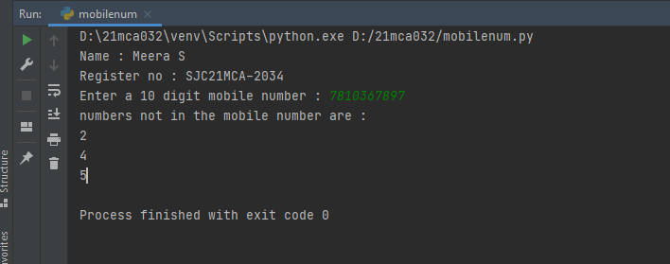

Co2

1. Create a three dimensional array specifying float data type and print it.

2. Create a 2 dimensional array (2X3) with elements belonging to complex data

type and print it. Also display

a. the no: of rows and columns

b. dimension of an array

c. reshape the same array to 3X2

3. Familiarize with the functions to create

a) an uninitialized array

b) array with all elements as 1,

c) all elements as 0

4. Create an one dimensional array using arange function containing 10 elements.

Display

a. First 4 elements

b. Last 6 elements

c. Elements from index 2 to 7

5. Create an 1D array with arange containing first 15 even numbers as elements

a. Elements from index 2 to 8 with step 2(also demonstrate the same

using slice function)

b. Last 3 elements of the array using negative index

c. Alternate elements of the array

d. Display the last 3 alternate elements

6. Create a 2 Dimensional array with 4 rows and 4 columns.

a. Display all elements excluding the first row

b. Display all elements excluding the last column

c. Display the elements of 1 st and 2 nd column in 2 nd and 3 rd row

d. Display the elements of 2 nd and 3 rd column

e. Display 2 nd and 3 rd element of 1 st row

f. Display the elements from indices 4 to 10 in descending order(use

–values)

7. Create two 2D arrays using array object and

a. Add the 2 matrices and print it

b. Subtract 2 matrices

c. Multiply the individual elements of matrix

d. Divide the elements of the matrices

e. Perform matrix multiplication

f. Display transpose of the matrix

g. Sum of diagonal elements of a matrix

8. Demonstrate the use of insert() function in 1D and 2D array

9. Demonstrate the use of diag() function in 1D and 2D array.

10. Demonstarte the use of append() function in 1D and 2D

array.

11. Demonstarte the use of sum() function in 1D and 2D array

1. Create a three dimensional array specifying float data type and print it.

print("Name : Meera S")  
print("Register no : SJC21MCA-2034")  
import numpy as np  
  
arr = np.array([[[1, 2, 3], [4, 5, 6]], [[1, 2, 3], [4, 5, 6]]], dtype='f')  
  
print("array is \n", arr)  
print("Data type is \n", arr.dtype)

OUTPUT

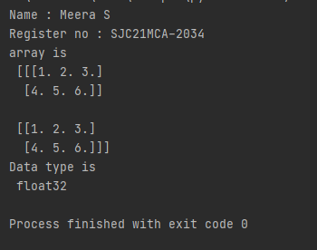

2. Create a 2 dimensional array (2X3) with elements belonging to complex data

type and print it. Also display

a. the no: of rows and columns

b. dimension of an array

c. reshape the same array to 3X2

print("Name : Meera S")  
print("Register no : SJC21MCA-2034")  
import numpy as np  
  
  
arr = np.array([  
  
 [1+4j,2+5j,3+6j],  
  
 [4+6j,9+1j,5+2j],  
  
 ],  
  
 dtype=complex)  
  
print(arr)  
  
print("\ndimension of given array is :", arr.ndim)  
  
print("\nnumber of rows and columns of given array is :", arr.shape)

OUTPUT

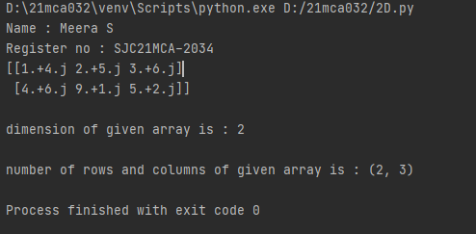

3. Familiarize with the functions to create

a) an uninitialized array

b) array with all elements as 1,

c) all elements as 0

print("Name :Meera S")  
print("Reg No : SJC21MCA-2034")  
import numpy as np  
myarr=np.empty((3, 3))  
print(myarr)  
print(np.zeros(3))  
print(np.ones(3))

OUTPUT

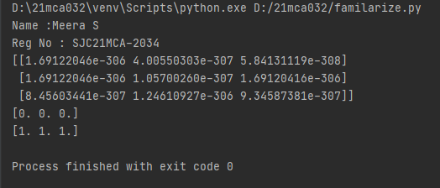

4. Create an one dimensional array using arange function containing 10 elements.

Display

a. First 4 elements

b. Last 6 elements

c. Elements from index 2 to 7

print("Name : Meera S")  
print("Register no : SJC21MCA-2034")  
import numpy as np  
mylist=np.arange(start=1, stop=11)  
print("The list is")  
print(mylist)  
firstfour=mylist[0:4]  
print("First 4 elements")  
print(firstfour)  
lastsix=mylist[4:11]  
print("last 6 elements")  
print(lastsix)  
index=mylist[1:7]  
print("index 2 to 7")  
print(index)

OUTPUT

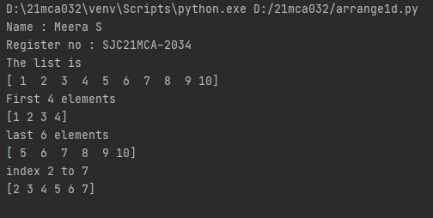

5. Create an 1D array with arange containing first 15 even numbers as elements

a. Elements from index 2 to 8 with step 2(also demonstrate the same

using slice function)

b. Last 3 elements of the array using negative index

c. Alternate elements of the array

d. Display the last 3 alternate elements

print("Name :Meera S")  
print("Reg No : SJC21MCA-2034")  
import numpy as np  
num=np.arange(2,32,2)  
print("First 15 even numbers")  
print(num)  
  
s=slice(2,8)  
print("Elements from index 2 t0 8")  
print (num[s])  
  
index=num[-3:]  
print("Last 3 elements of the array using negative index")  
print(index)  
  
alternate=num[::2]  
print("Alternative elements of the array")  
print(alternate)  
  
lalternate=num[15:9:-2]  
print("Last three alternate numbers")  
print(lalternate)

OUTPUT

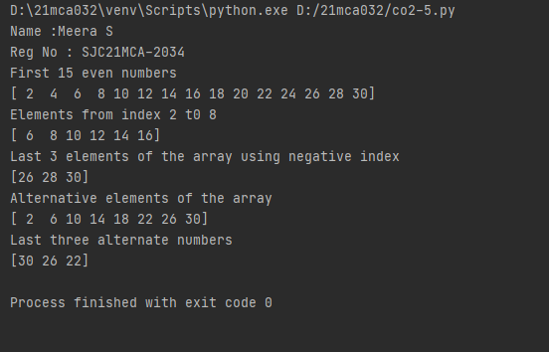

6. Create a 2 Dimensional array with 4 rows and 4 columns.

a. Display all elements excluding the first row

b. Display all elements excluding the last column

c. Display the elements of 1 st and 2 nd column in 2 nd and 3 rd row

d. Display the elements of 2 nd and 3 rd column

e. Display 2 nd and 3 rd element of 1 st row

f. Display the elements from indices 4 to 10 in descending order(use

–values)

print("Name :Meera S")  
print("Reg No : SJC21MCA-2034")  
import numpy as np  
X = np.array( [ [ 1, 6, 7, 4],  
 [ 5, 9, 2, 1],  
 [ 3, 8, 4, 6],  
 [ 2, 3, 6, 1] ] )  
print("Original form")  
print(X)  
  
print("Excluding the first row")  
print(X[1:,])  
  
print("Alternate method for Excluding the first row")  
num=np.delete(X,0,axis=0)  
print(num)  
print("Excluding last column")  
print(X[:, :-1])  
print("Display the elements of 1st and 2nd column in 2nd and 3rd row")  
print(X[1:3,0:2])  
print("Display the elements of 2nd and 3rd column")  
print(X[:,[1,2]])  
print("Display 2nd and 3rd element of 1st row")  
print(X[0:1,1:3])  
  
print("Display the elements from indices 4 to 10 in descending order")  
flat_array=X.flatten()  
print(flat_array)  
new=sorted(flat_array[-3:-10])  
index=flat_array[11:4:-1]  
print(index)

OUTPUT

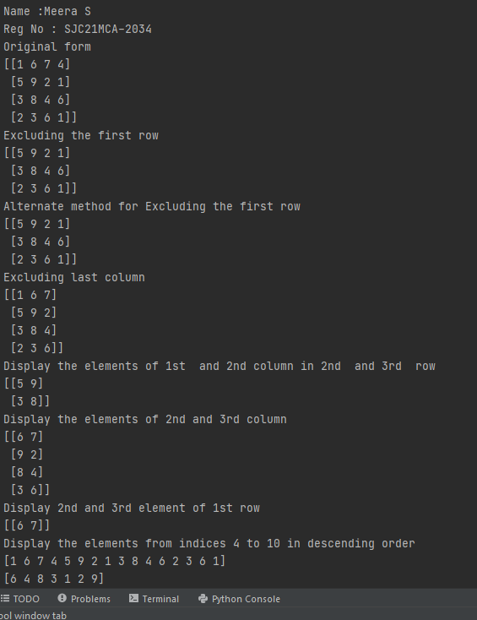

7. Create two 2D arrays using array object and

a. Add the 2 matrices and print it

b. Subtract 2 matrices

c. Multiply the individual elements of matrix

d. Divide the elements of the matrices

e. Perform matrix multiplication

f. Display transpose of the matrix

g. Sum of diagonal elements of a matrix

print("Name :Meera S")  
print("Reg No : SJC21MCA-2034")  
import numpy as np  
A=np.array([ [2, 4],[5, 6] ])  
B=np.array([ [9, 3],[9, 6] ])  
print("Matrix addition :")  
C=A+B  
print(C)  
print("Matrix Substraction :")  
C=A-B  
print(C)  
print("Multiply the individual elements of matrix :")  
C=np.multiply(A,B)  
print(C)  
print("Divide the elements of the matrices :")  
C=np.divide(A,B)  
print(C)  
print("Matrix Multiplication :")  
C=np.matmul(A,B)  
print(C)  
print("Display transpose of the matrix :")  
C=np.transpose(C)  
print(C)  
print("Sum of diagonal element of matrix :")  
C=np.diagonal(C)  
print("Diagonal elements are :")  
print(C)  
print("Sum of diagonal elements are :")  
print(sum(C))

OUTPUT

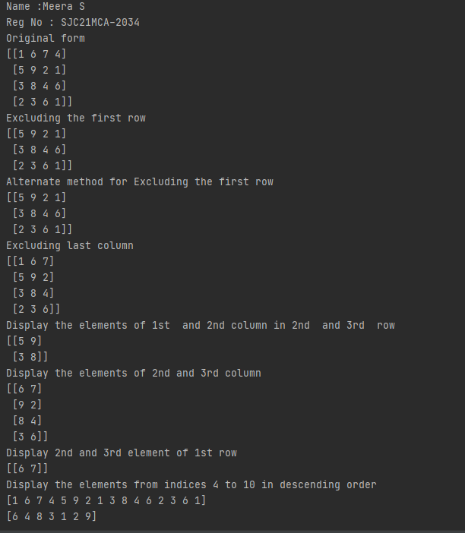

8. Demonstrate the use of insert() function in 1D and 2D array

print("Name :Meera S")  
print("Reg No : SJC21MCA-2034")  
import numpy as np  
  
arr = np.arange(5)  
print("1D arr : \n", arr)  
print("Shape : ", arr.shape)  
  
a = np.insert(arr, 1, 9)  
print("\nArray after insertion : ", a)  
print("Shape : ", a.shape)  
  
arr = np.arange(12).reshape(3, 4)  
print("\n\n2D arr : \n", arr)  
print("Shape : ", arr.shape)  
  
a = np.insert(arr, 1, 9, axis=1)  
print("\nArray after insertion : \n", a)  
print("Shape : ", a.shape)

OUTPUT

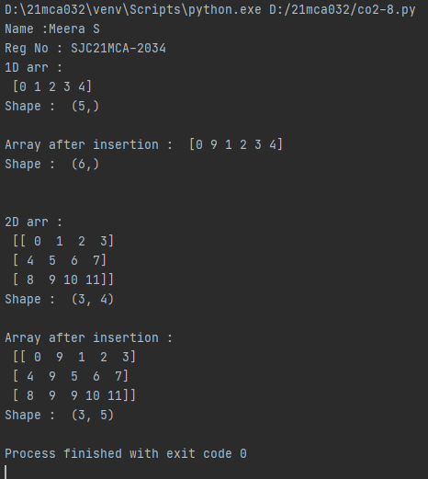

9. Demonstrate the use of diag() function in 1D and 2D array.

print("Name :Meera S")  
print("Reg No : SJC21MCA-2034")  
import numpy as np  
arr1=np.array([1,2,3,4,5,6])  
  
arr2=np.array([[1,2,3,4,5,6],[1,2,3,4,5,6],[1,2,3,4,5,6],[1,2,3,4,5,6],[1,2,3,4,5,6]])  
print(arr2)  
print(np.diag(arr2,k=1))

OUTPUT

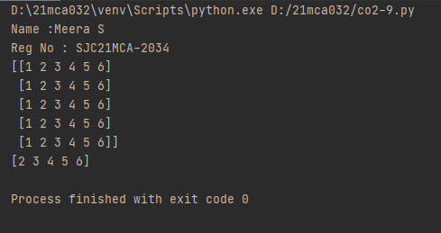

10. Demonstarte the use of append() function in 1D and 2D

array.

print("Name :Meera S")  
print("Reg No : SJC21MCA-2034")  
import numpy as np  
arr1=np.array([2, 3, 6, 5, 8, 4, 7])  
print("given array",arr1)  
newarr1=np.append(arr1,17)  
newarr2=np.append(arr1,[21,12,40,52])  
print("array after appending a value ", newarr1)  
print("array after appending mutiple values", newarr2)  
print(" ")  
A = np.array( [ [1, 5, 3],  
 [ 4, 2, 7] ])  
print("2d array",A)  
newarr2d = np.append(A, [20, 30, 40])  
print("after appending",newarr2d)  
print(" ")  
B = np.array([[70, 80, 90],  
 [61, 62, 63]])  
new = np.append(A, B , axis=1)  
print("array A",A)  
print("array B",B)  
print("appending two arrays A and B",new)

OUTPUT

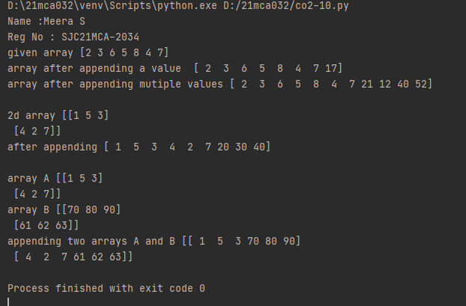

11. Demonstarte the use of sum() function in 1D and 2D array

print("Name :Meera S")  
print("Reg No : SJC21MCA-2034")  
import numpy as np  
arr1=np.array([1,2,3,4,5,6])  
  
arr2=np.array([[1,2,3,4,5,6],  
 [1,2,3,4,5,6],  
 [1,2,3,4,5,6],  
 [1,2,3,4,5,6],  
 [1,2,3,4,5,6]])  
  
print(np.sum(arr2))

OUTPUT

